
Department of CSE

B.Tech. CSE Trimester -5

Roll Number: 2520030493
Name: A.Nava Harsha

Cloud Infrastructure and Services
25CS2206E

LAB RECORD
2026

Experiment -1

AIM: To create an AWS free tier account to provision the resources.

Description:
This experiment demonstrates the process of registering for an Amazon Web Services (AWS) account and accessing the AWS Management Console. The account registration process includes email verification, selecting the available account plan, entering contact and billing information, confirming identity, and completing mobile verification.
Prerequisites: A valid email ID, mobile number, personal details, internet connection, and a payment method accepted by AWS. An identity document may also be required during verification.
The account is used to access AWS services and the resources available under the selected account plan.

Steps:

1. Open a web browser and visit the AWS Free Tier website: https://aws.amazon.com/free.
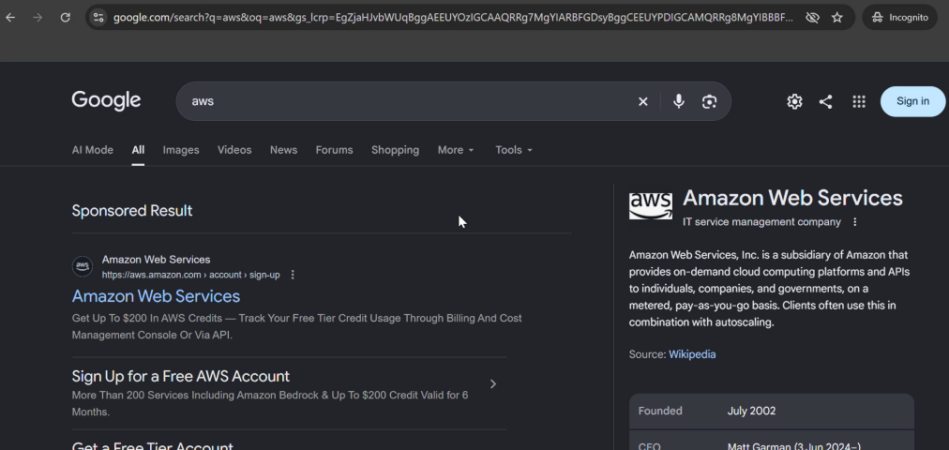
Figure 1: Opening the AWS website.
2. On the AWS Free Tier page, click Sign in to console.
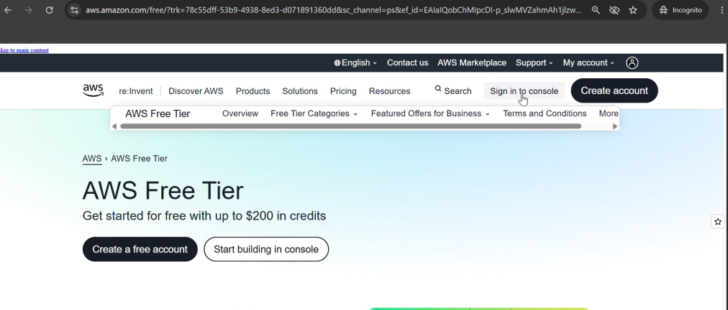
Figure 2: AWS Free Tier page and console sign-in option.
3. On the sign-in page, select Create a new AWS account.
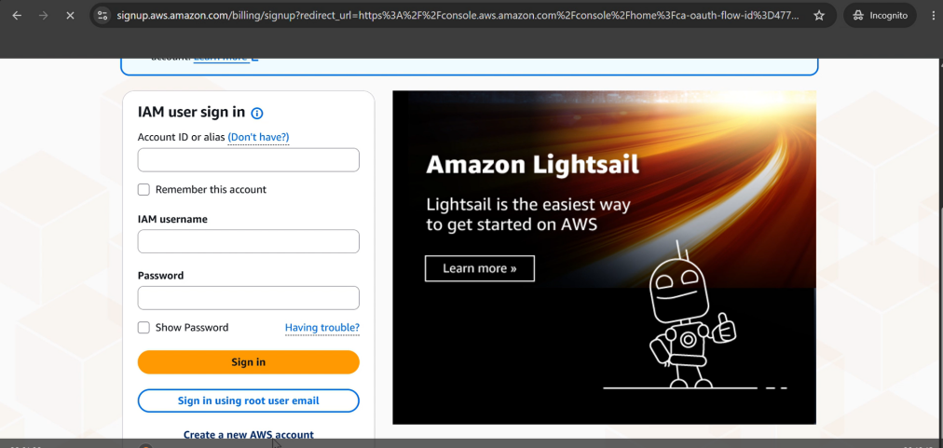
Figure 3: AWS sign-in page.
4. Enter the email address, password, and AWS account name.
5. Click Verify email address and enter the OTP sent to the registered email address.
6. Select the Free (6 months) account plan by clicking Choose Free plan.
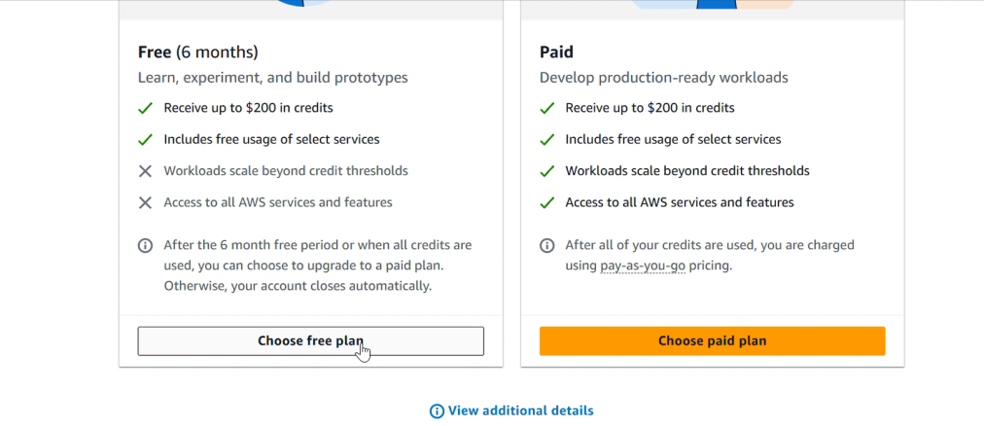
Figure 4: Selecting the Free account plan.
7. Enter the contact information, including full name, phone number, and address. Review the details, agree to the terms, and continue.
8. Provide the requested billing information using an available payment method, such as UPI or a debit/credit card.
9. Complete identity confirmation. Select Academic as the primary purpose of account registration and Individual as the ownership type. Provide an accepted identity document if requested.
10. Enter the mobile number, select Send SMS, and enter the verification code received.
11. Wait for AWS to complete the account setup process.
12. After setup is complete, open the AWS Management Console. If needed, visit https://console.aws.amazon.com and sign in using the registered root-user email address and credentials.
Output:
The AWS account registration process is completed and the AWS Management Console is accessible.
Verification:
• The AWS Management Console dashboard is visible.
• The AWS account name is displayed in the account menu.
• The account plan information is accessible.
• AWS services available under the selected account plan can be accessed.
Result: A new AWS account is successfully created, verified, and accessed through the AWS Management Console.

